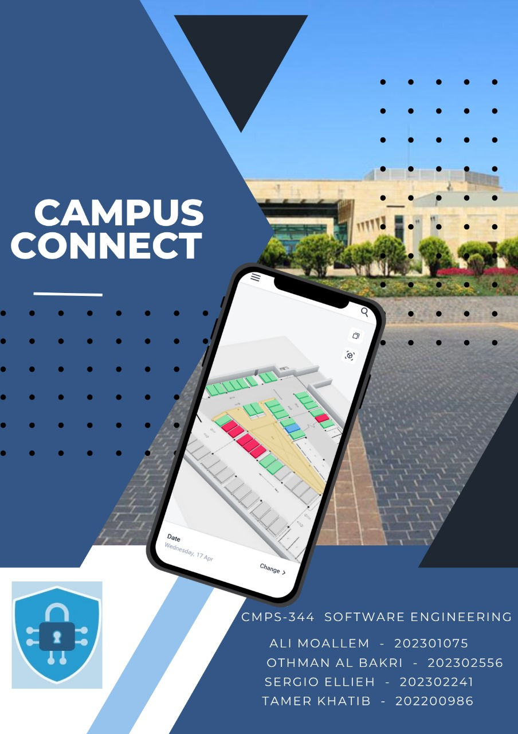

**Table of Contents**

**Chapter 1. Introduction 5**

**A. Main Project Description 5**

**B. Problem Statement 5**

**C. Project Goal 5**

**D. System and Domain Review 5**

**Chapter 2. Project Plan 6**

**A. SDLC Model 6**

**B. Project Organization 6**

**C. Ethical standards and guidelines 6**

**D. Schedule/Timeline 6**

**E. Feasibility Study 6**

**Chapter 3. Software Requirement Specification 7**

**A. Product Functions 7**

**B. User characteristics 7**

**C. Non-functional Requirements 7**

**D. Domain Requirements 7**

**E. Functional Requirements 7**

**Chapter 4. Project Design 8**

**A. User Interface Prototype 8**

**B. Data Flow Diagram 8**

**C. Database Diagram 8**

**D. Domain/Class/Object Diagrams 8**

**E. Sequence Diagrams 8**

**Chapter 5. Methodology 9**

**A. Implementation 9**

**B. Testing 9**

**C. Maintenance 9**

**Chapter 6. Conclusion and Future Work 10**

**Chapter 7. References 11**

**Appendices 12**

# **Chapter 1. Introduction**

## **Main Project Description**

The CampusConnect project aims to revolutionize campus management by addressing key challenges related to parking, operations, and security through the development of an integrated software solution. By leveraging advanced technology and data-driven insights, CampusConnect seeks to streamline parking processes, enhance operational efficiency, and improve security measures on campus. The project will investigate various research areas within campus management, focusing on the utilization of technology to optimize resource allocation, improve safety measures, and provide a seamless experience for campus stakeholders.

## **Problem Statement**

The main problems that CampusConnect aims to address include:

Congestion in parking areas: Inefficient parking management leads to congestion and frustration among students, faculty, and staff.

Inefficient resource allocation: Lack of real-time data insights hinders effective resource allocation, resulting in suboptimal utilization of campus facilities.

Security vulnerabilities: Traditional security measures may be inadequate in addressing modern security threats, leaving campuses vulnerable to incidents.

## **Project Goal**

The goal of CampusConnect is to provide a comprehensive and user-friendly platform that streamlines parking processes, enhances operational efficiency, and improves security measures on campus. By completing this project, we aim to create a solution that meets the needs of various stakeholders, including students, faculty, staff, and administrators. The target audience for the product includes all members of the campus community who interact with campus management systems on a regular basis.

## **System and Domain Review / Background**

Existing systems related to campus management often face challenges such as outdated technology, lack of integration, and limited scalability. Traditional parking management systems rely on manual processes and outdated infrastructure, leading to inefficiencies and frustrations for users. Similarly, security systems may lack real-time monitoring capabilities and fail to provide timely alerts in case of emergencies.

CampusConnect seeks to differentiate itself by offering a modern and integrated solution that leverages advanced technology such as real-time data analytics, mobile applications, and cloud computing. By providing users with a user-friendly interface and access to actionable insights, CampusConnect aims to improve the overall campus experience and enhance safety and security measures. Additionally, the system will prioritize scalability and flexibility to accommodate the evolving needs of campus management.

# **Chapter 2. Project Plan**

## **SDLC Model**

The Spiral SDLC model will be implemented for the CampusConnect project. The Spiral model merges the iterative characteristics of prototyping with the systematic elements of the waterfall model. Due to the complex nature of CampusConnect and the importance of thorough risk management, the Spiral model fits well with our project objectives. It enables the methodical recognition and reduction of risks at every stage, guaranteeing that possible problems are resolved at the beginning of the development process. By adopting the Spiral model, our goal is to progress through various rounds of development, integrating feedback and improving our solution in order to effectively address the changing requirements of campus management.

## **Project Organization**

Project Manager Tamer Khatib:  
Carries out an initial evaluation of risks and establishes project goals according to input from stakeholders.  
Manages the planning and implementation of every spiral cycle.  
Collaborates with stakeholders to collect input and determine project priorities.  
Guarantees that every round of work focuses on known risks and reaches project goals on time.  
Software engineer (Ali Moallem):  
Works together with the project manager and team members to establish requirements for every iteration.  
Develops and constantly improves software features and functionalities by incorporating user feedback.  
Adjusts to modifications in needs and design specifications during each spiral iteration.  
Regularly reviewing and refactoring code is done to uphold code quality and flexibility.  
Designer Sergio Ellieh:  
Develops initial design mockups for every cycle, with a key emphasis on user interface and user experience.  
Integrates input from stakeholders and usability testing to enhance design through iterative processes.  
Collaborates closely with developers to guarantee smooth incorporation of design elements in the software.  
Iteratively improves design elements by incorporating feedback from usability testing and stakeholder input.  
Quality Assurance (QA) Tester Othman Bakri:  
Creates test plans and test cases for every iteration, encompassing both functional and non-functional requirements.  
Carries out test cases and pinpoints defects or areas needing enhancement in the software.  
Gives the development team input on the software's quality and dependability.  
Works with stakeholders to decide which issues are most important and resolve them in the next rounds of work.

## **Ethical standards and guidelines**

We follow ethical principles and guidelines concerning data privacy, security, and user consent in our project. User privacy and data protection are our top priorities, guaranteeing that sensitive information is securely handled and in alignment with regulations like GDPR and HIPAA. Furthermore, prior to collecting any personal data, we will ensure to obtain consent from users and maintain transparency in terms of data usage and storage protocols.

## **Schedule/Timeline**

Sprint 1 (May - June): Requirement Gathering and Analysis

Sprint 2 (July - August): Design and Prototyping

Sprint 3 (September - October): Implementation and Testing

Sprint 4 (November - December): Deployment and Maintenance

Each member or sub-group within the team will be allocated specific tasks and responsibilities according to the project timeline. Developers will spend approximately two sprints working on each major feature listed in the product description, with the design phase overlapping with the first sprint.

## **Feasibility Study**

Risk management is crucial for the success of the CampusConnect project, particularly considering the spiral SDLC model's iterative nature. Several risks need to be addressed to ensure smooth project execution:

**Technical Risks:**

Potential technical challenges such as integration issues with existing campus systems or scalability issues.

Resource risks involve the possibility of not having enough skilled team members or necessary hardware and software resources available.  
Security Risks: Dangers linked to data breaches or cyber-attacks on the system.  
In order to reduce these risks, preventive actions will be implemented.

**Technical Feasibility**

The technical feasibility of the CampusConnect project is high, given the availability of established technologies and frameworks in the market. Key components of the technical stack include:

Apache Kafka supports mobile and desktop platforms like iOS, Android, Windows, and MacOS.  
Programming languages used for frontend and backend development are Dart, HTML, CSS, JavaScript, and React for frontend, and Python, Java, Node.js, and PHP for backend.

Database: SQL for efficient data management.

Frameworks: React Native, Flutter, and Electron for cross-platform app development.

Libraries: Django, Flask, Express.js, React Native, and Flutter libraries for enhanced functionality.

Development Tools: Visual Studio, PyCharm, Android Studio, GitHub, Firebase, and YourKit for streamlined development and monitoring.

**Economic Feasibility**

An economic feasibility study will be conducted to assess the financial viability of the CampusConnect project. This includes:

Assessment of the budget needed for project advancement, taking into account development expenses, licensing charges, and continual maintenance costs.  
Evaluating the projected schedule for finishing the project to guarantee it remains on track with the designated budget and timeline delivery.

Once finished, the CampusConnect system will be provided to various end-users, such as students, faculty, staff, and administrators.

Delivery documentation will include:

Documentation such as user guides, admin guides, release notes, and help menus are available to help users effectively utilize and comprehend the CampusConnect system.  
The CampusConnect project aims to provide a strong, easy-to-use solution that addresses feasibility aspects and meets the needs of campus stakeholders while improving campus connectivity and security.

# **Chapter 3. Software Requirement Specification**

## **Product Functions**

Management of parking facilities.  
Enable users to locate parking spots that are accessible on the campus.  
Offer live updates on the availability and occupancy of parking spaces.  
Allow users to pre-book parking spaces.  
Incorporation of payment systems for parking charges.  
Stretch Feature 1: Incorporation with GPS systems to direct individuals to open parking spaces.  
Feature 2: Users can share parking spots to improve efficiency.  
Managing the production process:  
Optimize allocation and use of campus resources.  
Monitor and oversee campus properties, tools, and assets.  
Allow users to ask for and book campus services.  
Offer analysis and observations on how resources are used to improve efficiency.  
Feature 1: Automatic scheduling and assignment according to user preferences.  
Stretch Feature 2: Enhanced planning through integration with campus events and activities.  
Management of security concerns.  
Improve security measures and protocols on campus.  
Offer live monitoring of campus premises and entry points.  
Activate functions for reporting incidents and responding to emergencies.  
Incorporating with campus security systems for smooth coordination.  
Feature 1: Use facial recognition technology to control access.  
Enhancement 2: Incorporation with emergency notification systems for immediate alerts.  
Management of users:  
Administer user accounts, profiles, and permissions.  
Offer customized user interactions according to specific roles and preferences.  
Implement authentication and authorization methods to ensure safe access.  
Incorporation with university directory and login systems.  
Feature 1: Seamless user authentication through integration with social media platforms.  
Stretch Feature 2: Improved security with multi-factor authentication.

## **User characteristics**

The target users of the CampusConnect system include students, faculty, staff, and administrators of the campus community. Users may vary in their technical proficiency and familiarity with campus management systems; thus, the system should provide a user-friendly interface and intuitive navigation to accommodate users of all levels.

## **Non-functional Requirements**

System performance should involve responsiveness and the ability to manage multiple user interactions simultaneously without causing any noticeable delays.

Data security and privacy must be protected by using encryption, access controls, and secure authentication methods.

Dependability: The system needs to be dependable and accessible for utilization constantly, with limited interruptions for upkeep or enhancements.

Scalability: The system must have the capacity to expand in order to handle increases in user base and data volume as time goes on.

Ease of use: The system needs to be user-friendly and straightforward, offering users clear guidance and instructions.

## **Domain Requirements**

The CampusConnect system should comply with relevant regulations and standards related to campus management, data privacy, and security. Additionally, it should integrate seamlessly with existing campus systems and infrastructure, such as parking facilities, security systems, and administrative databases.

## **Functional Requirements**

Scenario 1: User Locates an Empty Parking Space.  
Description: The user is looking for parking spaces that are open on the campus.  
Diagram displaying use cases included.  
Purpose: This use case focuses on improving parking management by helping users find parking spaces easily and easing traffic congestion.  
Scenario 2: User Books a Parking Space  
Description: A user books a parking space ahead of time.  
Diagram demonstrating the use case: [Diagram included]  
Argument: By allowing users to make parking reservations in advance, this use case increases user convenience and helps with better planning, lowering the chances of parking unavailability.  
Scenario 3: User Notifies about Security Breach  
A security incident or suspicious activity on campus is reported by a user.  
Diagram of Use Case: [Insert diagram]  
Argument: This use case allows for quick reactions to security threats and improves campus safety by allowing users to report incidents instantly.  
Scenario 4: Admin Controls Campus Assets  
A campus administrator oversees facilities, equipment, and resources on the campus.  
Diagram demonstrating the use case: [Insert diagram]  
The rationale behind this case assists in effective allocation and usage of resources, allowing administrators to enhance campus operations.  
Scenario 5: Employees Seek Assistance with Campus Amenities  
Description: An employee asks for help with campus services or repairs.  
Diagram representation for a use case: [Diagram included]  
Argument: This use case enhances operational efficiency by simplifying service requests and guaranteeing prompt response to staff requirements.

# **Chapter 4. Project Design**

## **User Interface Prototype**

## Sketch of the user interface for managing parking. Description: The main screen for parking management in the CampusConnect app is illustrated in this UI sketch. Individuals have the ability to look for open parking spaces, see current parking availability, and book parking spaces ahead of time. The interface offers filtering choices for parking spots based on location, availability, and user preferences. Draft of the User Interface for Reporting Security Incidents: This UI design shows the layout for reporting security incidents or suspicious activities on campus. Users can conveniently utilize the reporting feature found in the main menu to input information on the incident such as location, description, and urgency level. The interface has features for adding images or extra details to the report. These interface drawings depict the main features and functions of the CampusConnect system, showing users how they can use the app to find parking and report security issues.

## **Data Flow Diagram**

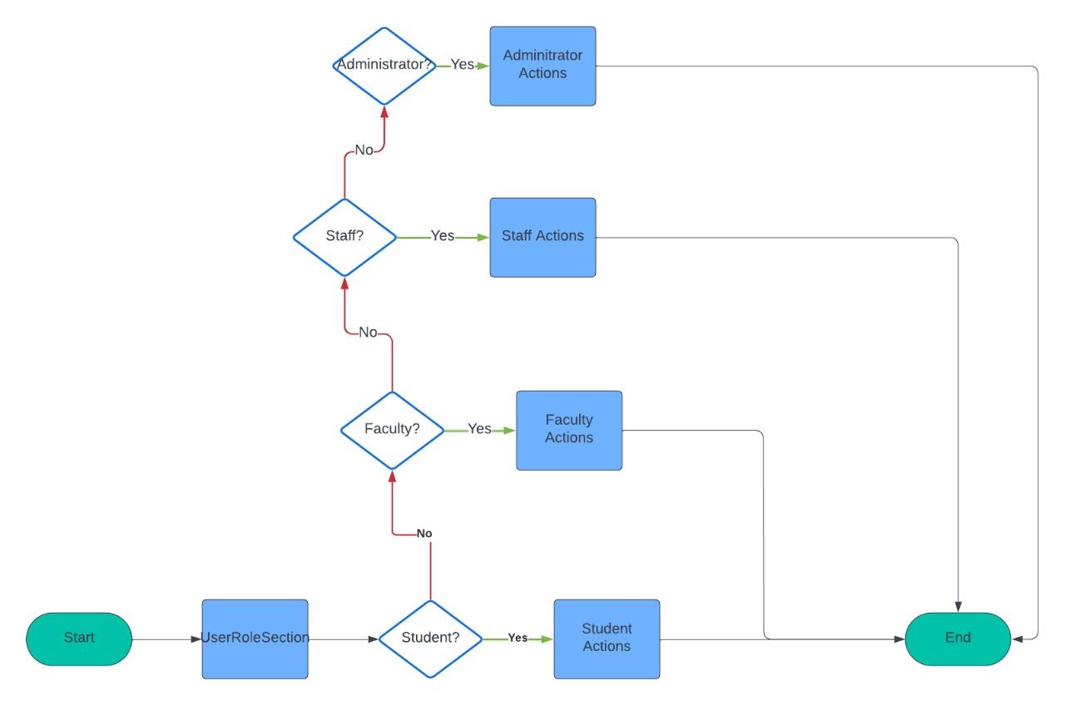

## **Database Diagram**

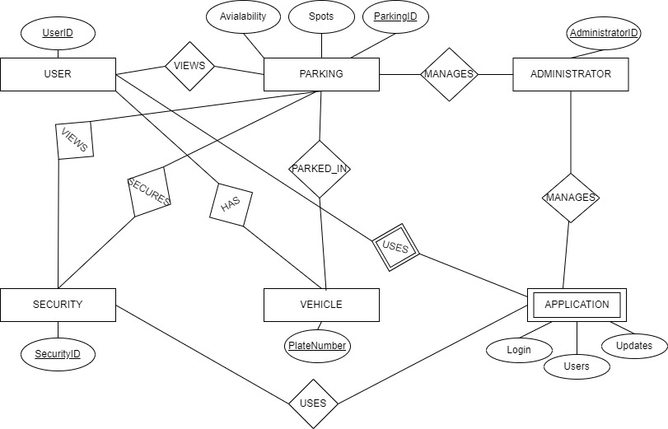

## **Domain/Class/Object Diagrams**

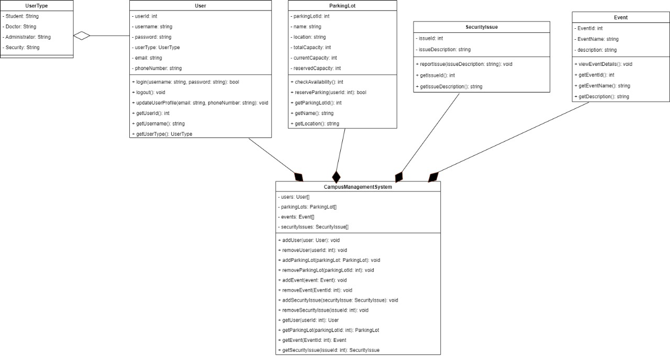

## **Sequence Diagrams**

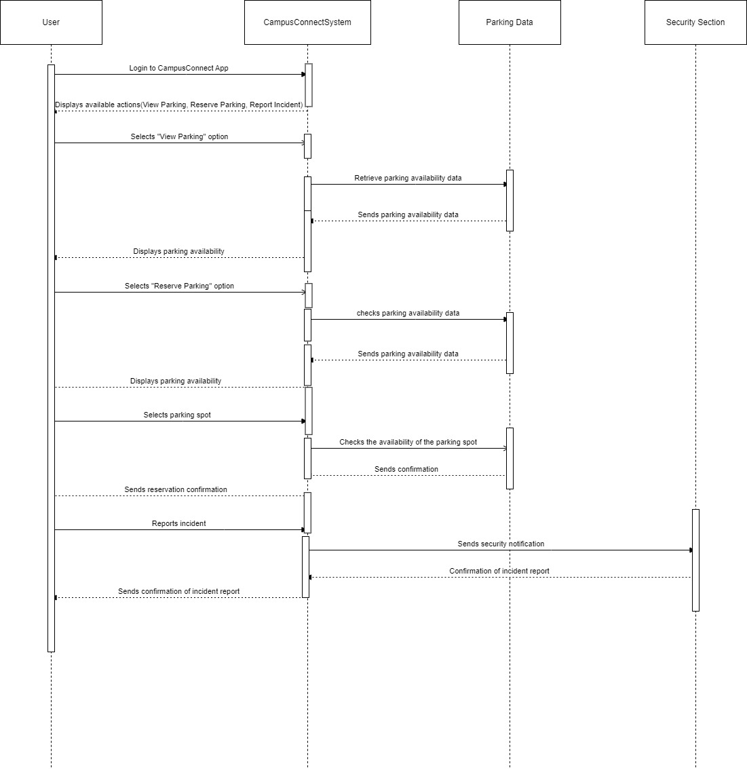

## **Use Case Diagrams**

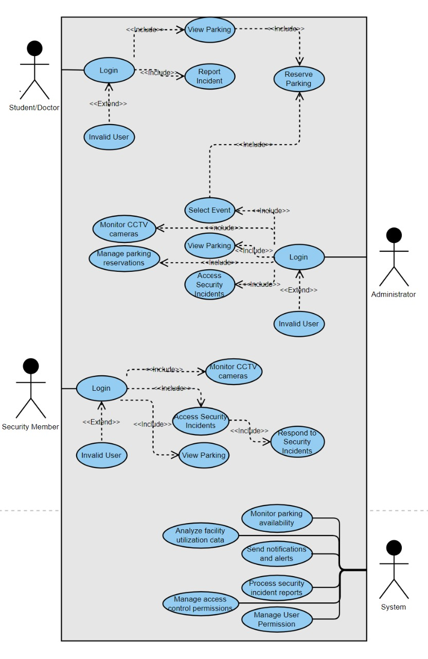

# **Chapter 5. Methodology**

## **Implementation**

1.Platforms and operating systems:

a. Mobile and Desktop

b. Windows, MacOS, IOS, Android

c. Apache Kafka

2.Programming Languages:

a. Frontend languages: Dart, HTML, CSS, JavaScript, React

b. Backend languages: Python, Java, Node.js, PHP

3.Database:

a. SQL

4.Frameworks:

a. React Native

b. Flutter

c. Electron

5.Libraries:

a. Django

b. Flask

c. Express.js

d. React Native library

e. Flutter library

6.Development Tools:

a. Visual Studio

b. PyCharm

c. Android Studio

d. Github

e. Firebase (Monitoring tool)

## f. YourKit (Monitoring tool)

## **Testing**

We intend to carry out thorough testing during all stages of development to verify the reliability, functionality, and usability of the CampusConnect system. The aspects that will be included in our testing strategy are as follows:  
Unit Testing involves testing separate components and modules independently to ensure they work correctly and pinpoint any glitches or mistakes. We will employ tools such as Jest and Pytest to conduct automated unit testing.  
Integration Testing is the process of testing that checks how different components and subsystems interact and integrate with each other to guarantee smooth operation. We will conduct API testing to verify the exchange of data between the frontend and backend components.  
System Testing involves examining the entire system to confirm that it behaves and performs according to the specified requirements. This involves testing user workflows and scenarios from start to finish.  
Usability Testing involves collecting input from actual users to assess the user interface design, navigation flow, and overall user experience of the CampusConnect system. We will perform usability testing with users who are representative in order to discover any issues with usability and find areas that can be enhanced.  
We will employ test suites that align with the requirements outlined in the Software Requirement Specification (SRS) document to verify thorough testing of all functional and non-functional requirements. Test cases will be carefully recorded and carried out in an organized manner, with any problems or flaws found during testing being dealt with promptly.

## **Maintenance**

We will use the following tools for version control, bug tracking, and other maintenance tasks:

Git is used for handling code repositories and monitoring modifications in various software versions.

Tracking bugs and managing software issues during development and testing can be done using Jira or Trello. These tools help keep track of bug reports, feature requests, and other issues.

Implementation of Continuous Integration and Deployment (CI/CD): Our goal is to set up CI/CD pipelines with Jenkins or GitHub Actions to automate the building, testing, and deploying procedures for achieving consistent and dependable software releases.

Through the utilization of these tools and methods, our goal is to make the development process more efficient, enhance the quality of the software, and simplify the ongoing maintenance and updates for the CampusConnect system.

# **Chapter 6. Conclusion and Future Work**

The CampusConnect system marks a breakthrough in campus management, addressing parking, operations, and security challenges. Developed collaboratively with agile methodologies, it boosts efficiency, accessibility, and safety.

Moving forward, we plan to:

Expand features based on feedback and needs, integrating smart technologies.

Enhance scalability and performance with cloud solutions.

Refine user experience through testing and research, ensuring accessibility.

Strengthen security with advanced measures.

Integrate with existing campus systems for seamless operation.

We're also exploring using the system in other public spaces for enhanced security.

In essence, CampusConnect sets a new standard in campus management, promising ongoing innovation and safer, smarter environments for all.